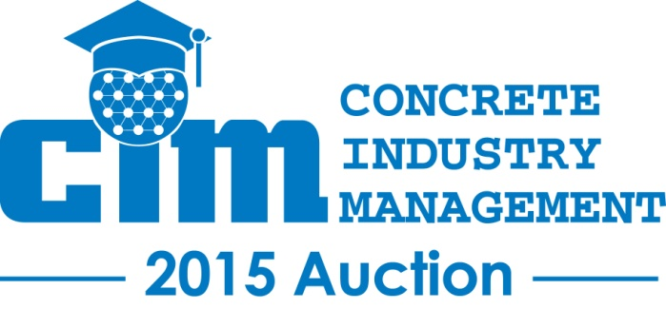
Wednesday, February 3, 2016
Silent Auction 11:00am – 12:45pm PST (Room N263)
Live Auction 1:00pm – 2:00pm PST (Room N262)
Las Vegas Convention Center
Las Vegas, NV

REGISTRATION & PARTICIPATION INSTRUCTIONS

IF YOU WILL BE ON-SITE IN LAS VEGAS AT THE SHOW:

- Step 1: Use your cell phone and text CIM16 to 24700 and follow the instructions. This will give you access to the silent auction site, where beginning January 20th you will be able to place bids on all of the items in the silent auction. This is how you will continue to bid on silent auction items through the event. This process will also pre-register you for the live auction. If you would prefer to register using your computer, visit http://cim16.auction-bid.org.

- Step 2: Beginning at 11am PST on the morning of the auction, come to room N263 and pick up your bid book for the live auction, at which time you will be provided with your bidder number. You will use this bidder number to bid on all of the items in the live auction (the phone app is not used for bidding on live auction items).

IF YOU WILL NOT BE ON-SITE IN LAS VEGAS:

- Step 1: Visit https://www.rbauction.com/heavy-equipment-auctions/c-i-m-charity-auction for details and to register to bid in real-time through the internet on all of the items in the LIVE auction.

- Step 2: On your cell phone, CIM16 to 24700 and follow the instructions. This will give you access to the silent auction website, where beginning January 20th you will be able to place bids on all of the items in the silent auction. This is how you will continue to bid on silent auction items through the event.

For a list of all of the items to be auctioned, separated by category, visit http://www.concretedegree.com/auction/current-auction-items/.
Check back often as new items are added daily!

Questions or difficulties registering? Contact Nicole Maher at nmaher@nrmca.org or 240-485-1158 for assistance.

